Connecting to RDS

- Using a web browser, navigate to rds.syr.edu.
- Depending on your affiliation with the university, choose a connection:
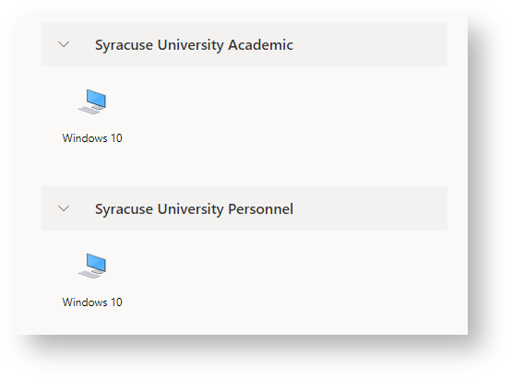
- If this is your first time logging into RDS, or if you're logging in after clearing your browser history (including cache and cookies), you'll be presented with a popup dialog box. This box will ask for permission to allow the remote computer to access certain functions on your device. If you'd like to prevent this popup from appearing in the future, simply check the box labeled "Don't ask me again for connections to this computer."
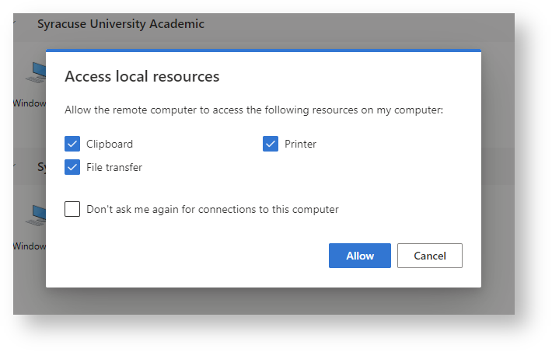
- If you are not logged in already, you will be prompted to do so using your email address (NetID@syr.edu) and NetID password.
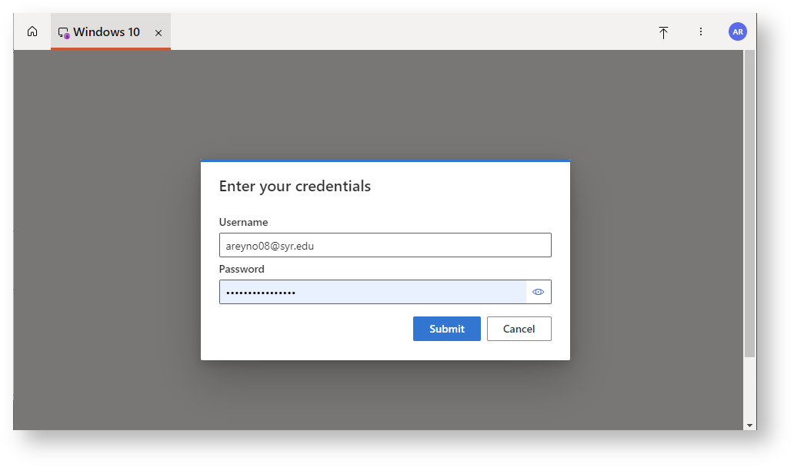
- To sign out of your session, navigate to the Start menu, click on your name or profile picture, and then select "Sign Out."
