FACULTY PORTFOLIO SYSTEM

Resource Guide for Using Workflow
(CV updates and other important forms)

Syracuse University Office of Academic Affairs Institutional Effectiveness vita@syr.edu

Table of Contents
Introduction and How to Log In 1
Home Page Navigation 2
3 Steps to Completing your CV Update 3
Activities 4
Adding or Editing Activities 5
Running Reports 6
Important Forms 7
Filling Out Important Forms 8
Submitting Your Materials Through Workflow 9

Introduction and How to Log In

Introduction:

The Faculty Portfolio System (FPS) is a customizable web-based application that is used to create your CV, dossier for promotion/tenure, annual updates, accreditation reports, and web profiles.

Important Reminders:

- If you have questions, email us at vita@syr.edu. We are here to help!

- Some fields are Read Only – a lock icon will be displayed next to these fields. They are auto populated from an official information source, like PeopleSoft.

- In most areas, you need to have at least one date associated with an activity (such as a start or end year) for accurate reporting.

- The Office of Institutional Effectiveness (IE) has entered data on your behalf, but we need your help verifying accuracy.
Logging In:

There are 3 ways to access your portfolio:

- https://facultyportfolio.syr.edu

- The Faculty Portfolio link in your Faculty and Advisors tile on MySlice.

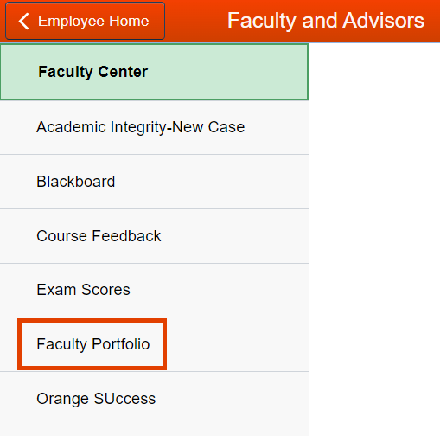

- https://effectiveness.syr.edu/facultyportfolio/

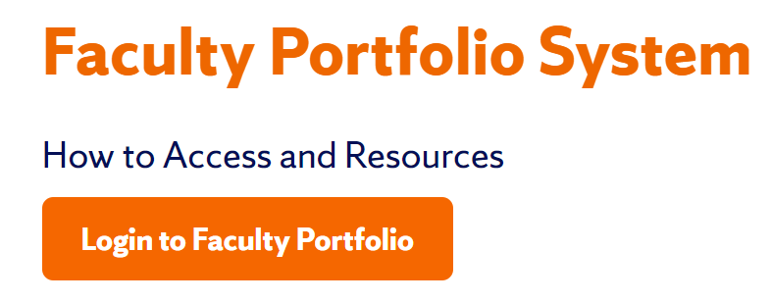

Home Page Navigation

Once you have logged into the Faculty Portfolio System (FPS), along the top of your screen is the Navigation Bar.

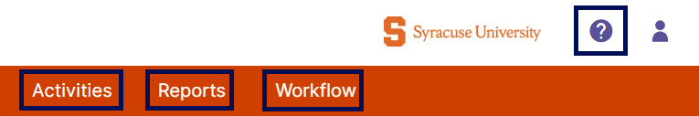
1
2
3
4

- The Activities tab is where you will add and/or update your CV information.
- The Reports tab can be used to pull different reports on your CV information.
- The Workflow tab is where you will submit your materials.
- The Help function in the upper right corner contains links to resource guides about the FPS.

3 Steps to Completing your CV Update

- Update your activities. See pages 4 and 5.

- Create the CV Update form for the year requested. See pages 7 and 8.

- Submit via Workflow. See page 9.

Activities
The Activities screen contains six different sections: (1) Important Forms, (2) General Information, (3) Career Information, (4) Teaching/Mentoring, (5) Scholarship/Research, and (6) Service. Sections 2-5 are then further broken down into different types of activities or information that are typically included on a CV.
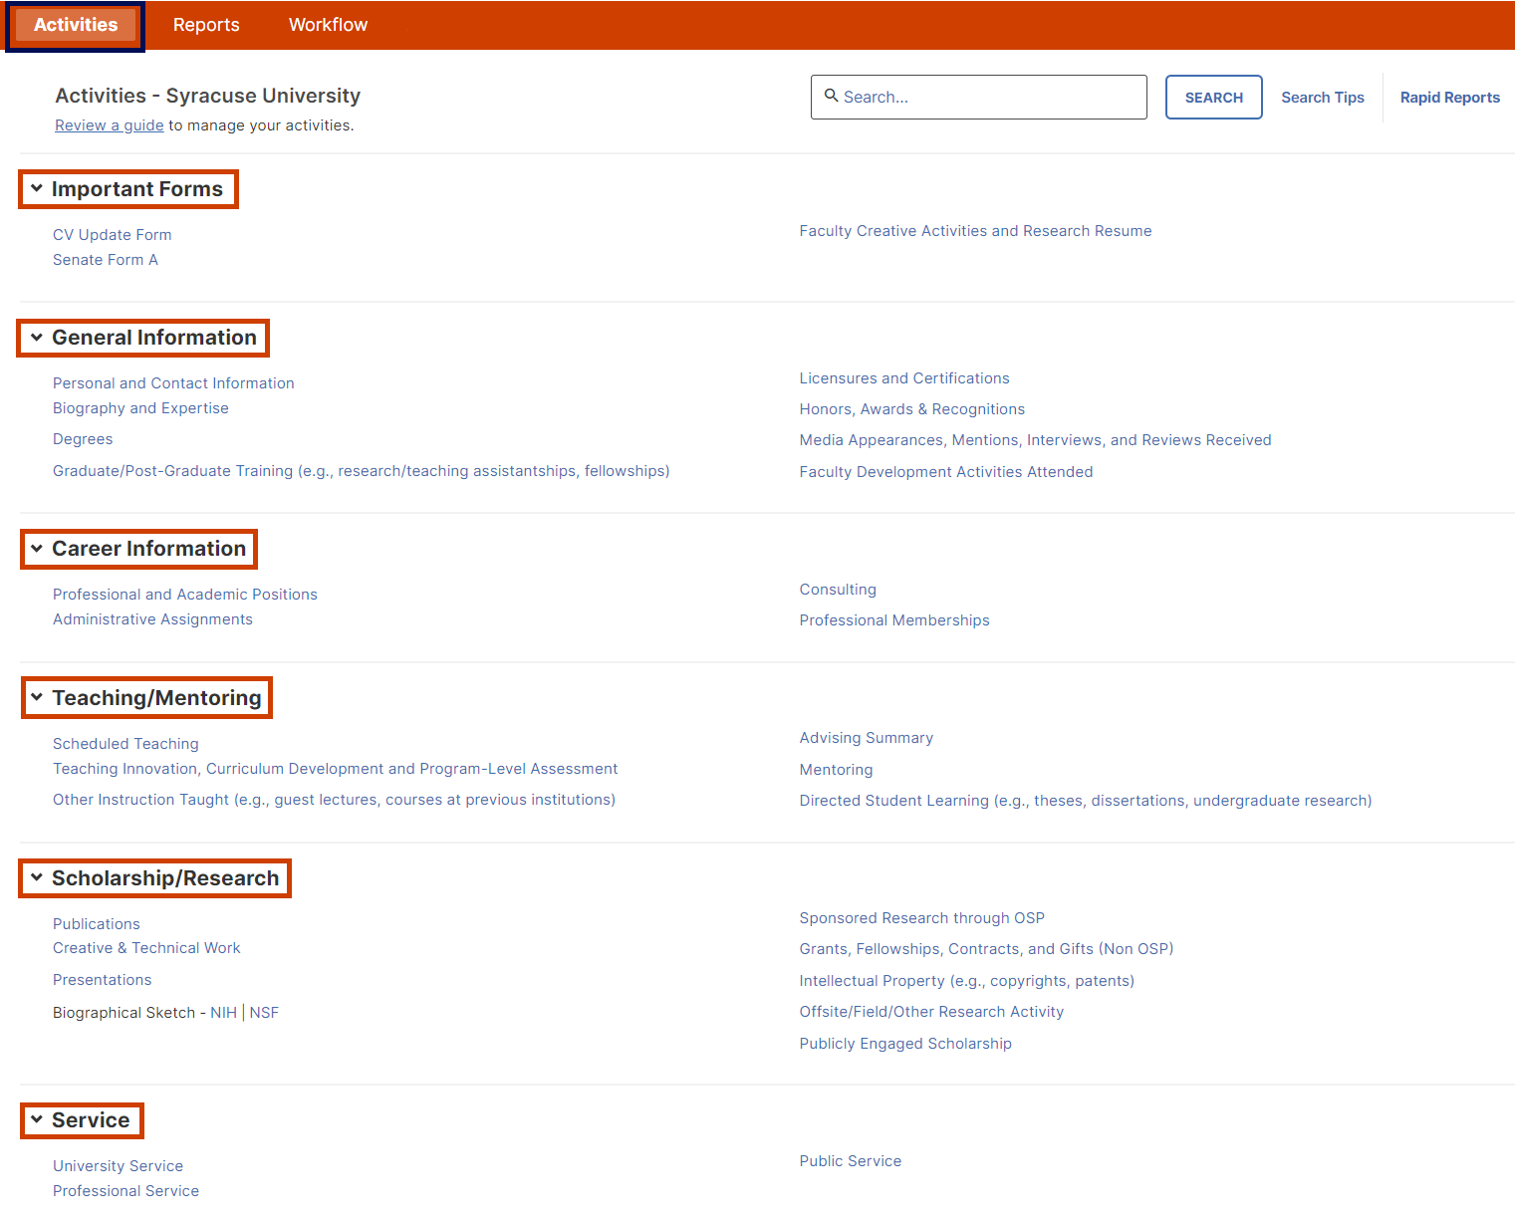
1
2
3
4
5
6

Adding or Editing Activities

Upon your review, you may need to add to or edit some of the information that has been entered on your behalf. To edit, select the appropriate subsection on the Activities screen, locate the record, and edit as needed. Make sure to always save your changes before moving on!

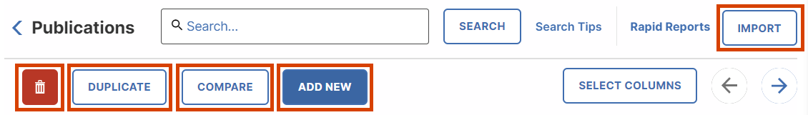
2
3
4
5
1

- The Trash Can icon enables you to delete a record.
- The Duplicate feature enables you to copy a selected record and edit some parts of it before saving for faster updating/importing.
- The Compare feature enables you to compare and merge 2-6 records, keeping the desired parts selected from each one.
- The Add New feature is how you add new records.
- The Import feature is only available within the Publications section – it brings you to a screen that assists you in importing your publications via:
  - BibTeX file from other software or databases such as EndNote, Google Scholar, Mendeley, RefWorks,
HeinOnline, and Zotero; or
  - Third-Party aggregator, such as ORCiD, Scopus, Web of Science, Crossref, or PubMed.

Running Reports
In the upper right corner below the Navigation Bar, select the Rapid Reports button. This tool enables you to run and download reports based on the information in the system.

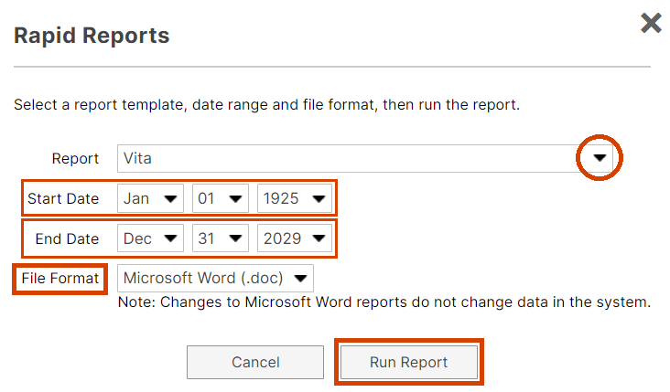
2
1
3
4
5

- Different report types are available to you through the Rapid Reports tool. To run a report of your full CV, select the Vita option from the report drop-down menu.
- To ensure you are pulling all possible information from the system, use a Start Date of January 1, 1925.
- Select an End Date of the current date or a future date if you know you have future/upcoming entries listed.
- Three file format options are available for output – Microsoft Word (.doc), PDF, or Web Page (.html). Please be aware that any changes made within these downloaded outputs will NOT change data in the system.
- Select Run Report and check your downloads folder on your computer to access your report.

Important Forms
There are two standard forms that display for all faculty (CV Update and Senate Form A), but depending on your school/college, there may be other forms available to you in this section.

The form(s) you fill out will depend on the review process you need to complete, as well as your faculty rank. If you are unsure about what form to fill out or if you need to fill out a form, check the instructions in your Workflow tab. To get started, select the appropriate form, and click Add New.

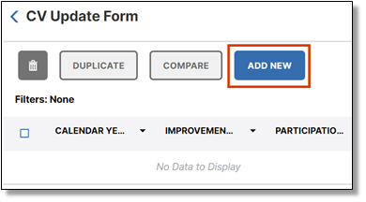

Filling Out Important Forms

Throughout the screen, there are guiding instructions that will tell you where information is being pulled from to help pre-populate your form. (1) Some sections will pull all records from a particular screen, (2) while others will pull records matching certain criteria from a screen. (3) There are also text boxes throughout for you to provide the same open-ended responses to questions that you would have previously done on the paper versions of these forms. (4) When you’re finished, make sure to click Save. You can come back at any time to update and/or finish your work by clicking on the record.
4
1
2
3
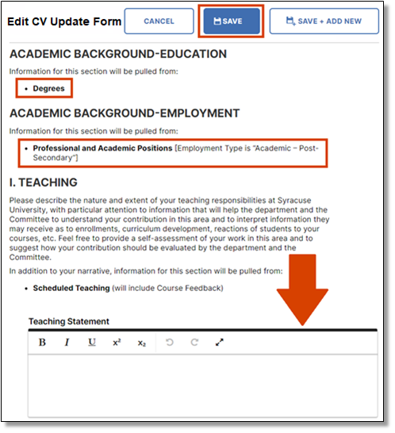

Submitting Your Materials Through Workflow
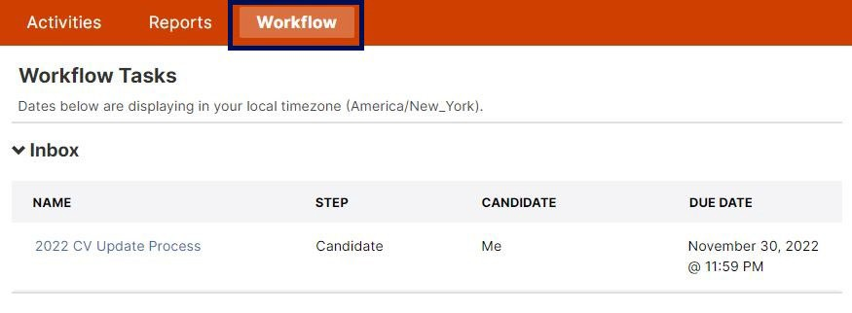
To review the instructions for your review process and/or to submit your materials, go to the Workflow tab in the top navigation bar, and click on the link in your Inbox – the name of this link will vary depending on the current process you need to complete.

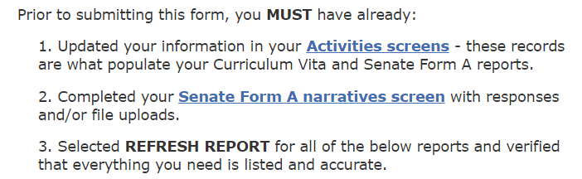
Throughout this screen, there will be instructions guiding you on how to prepare your materials for submission. This may include what forms you need to fill out, as well as if you need to upload additional documents on this page.

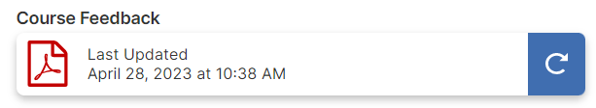
For any auto populated reports that are being included, you need to select either the Refresh All Reports button that will appear at the top of the screen in a message with a blue background, or individually click the blue refresh arrow buttons for each report.
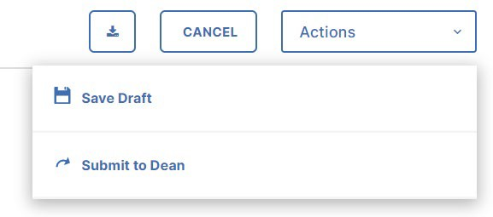
When you are satisfied with all of your materials and ready to submit, click on the Actions dropdown menu in the upper right corner and select the Submit option (the wording of who this is being submitted to will vary depending on the process and your school/college).

