Using Gradescope with Blackboard as an Instructor
[Gradescope article adapted with notes for Syracuse University]

Getting started
Gradescope integrations with Learning Management Systems (LMSs), such as Blackboard, are available with an institutional Gradescope license. When you access Gradescope through Blackboard, you and your students won't need to create or use a separate Gradescope password, because you will be authenticated via your Blackboard credentials. If you already have a Gradescope account under the email address that's associated with your Blackboard account (e.g., your school email), when you access Gradescope in Blackboard you will be taken to your existing account. If you do end up with multiple accounts under multiple emails, you can merge accounts.
Below is the general process you should follow to be able to use Gradescope with Blackboard. In this guide, you'll find specific details for completing each of these steps and links to other pertinent Gradescope Help Center articles.
- Step 1. Determine your LTI version.
  - At Syracuse University, Gradescope is integrated with Blackboard via LTI 1.3.
- Step 2. Link your courses.
- Step 3. Sync your roster.
- Step 4. Set up your assignment.
- Step 5. Grade submissions.
- Step 6. Post grades.

Linking your courses
Linking one Blackboard course to multiple Gradescope courses: If you have several courses on Gradescope that correspond to a single Blackboard course, it is not recommended that you link your Blackboard course to Gradescope. Linking courses, in this case, would allow students to enroll in any of the Gradescope courses that are associated with the single Blackboard course.

Students are automatically added to the Gradescope roster once they select a Gradescope course or assignment link within Blackboard.
- Log in to Blackboard. Click on the Blackboard course you'd like to link to Gradescope. If you don't see the course you need, contact your Blackboard administrator.
- Next, click Tools (Original) or Books & Tools (Ultra), and then click Gradescope Course. Depending on your institution's settings, this will launch Gradescope in a new tab or in an embedded window in Blackboard Original/Blackboard Ultra.
- Once Gradescope launches, you'll see a dialog box with course-linking options. Choose to link to a new or existing Gradescope course, and then click Link Course to go to the Course Settings page.
New Gradescope users: At this point, a new Gradescope account will be created for you if you do not already have one associated with the email address (e.g., your school email) that you use in Blackboard.
Existing Gradescope users: If you already have a Gradescope account under the email address that's associated with your Blackboard account (e.g., your school email), a new Gradescope account will not be created for you, and clicking the Gradescope link in Blackboard will take you to your existing account.
- On the Course Settings page, you can update the course title, description, rubric types, and score bounds. Keep in mind that course title and description changes made here will only appear in Gradescope, not in Blackboard.
- When you're finished, click Update Course. Your course is now linked and your students can access this Gradescope course. Now, it's recommended that you sync your roster.
Syncing your roster
You will only be able to sync your roster for courses that are set as available to students.
- Navigate to your course in Gradescope. If you are accessing Gradescope from Blackboard:
  - Select your course in Blackboard.
  - Select Tools if you are using the Original version of Blackboard or Books & Tools if you use Ultra.
  - Select Gradescope. This will open your course dashboard in the Gradescope view.
- Expand Gradescope’s left sidebar (if it isn’t already) and select Roster.
- Select Sync Blackboard Roster at the bottom of the page. The button may be customized by your institution to reflect whatever you call Blackboard internally. The standard text will display Sync *** Roster.
- A modal will appear explaining how user accounts will be synced. All names, emails, and student IDs will be auto-synced from Blackboard. User roles may also be synced depending on how your integration was initially configured. You may be asked to:
  - Decide whether to allow Gradescope to automatically email users to notify them they have been added to the course.
  - Sync Group Set to Sections - Decide whether to sync a group set from Blackboard to the Sections field in the Gradescope roster. This option will only appear if it has been enabled in the integration settings by an admin.
    - The Sections field on the Gradescope roster is used for grading questions by section and is an added column in all data exports.
We only recommend enabling syncing group sets to sections if you use Blackboard groups to associate students with a section on course rosters.
- Select Sync Roster when you are ready, or Cancel if you change your mind.
Remember to re-sync if users are added or dropped within Blackboard. Any existing submissions and grades assigned to dropped students will be preserved in Gradescope.
View or edit student information by hovering over their name in the roster and selecting Edit. Here you will be shown:
- First Name
- Last Name
- Email Address
- Student ID
- Section Name (if applicable)
Check out our Adding Students and Staff guide for more tips, like editing your roster or how to add sections manually.
Having issues with your roster sync? See the Troubleshooting section at the end of this page.

Setting up your assignments
- If you're using Blackboard Original, go to your course homepage in Blackboard > click Content (left sidebar) > click Build Content (header bar) > select Gradescope.
In Blackboard Ultra, go to your course homepage > click the + button under Course Content > click Content Market > you will see two Gradescope buttons > select Gradescope Assignment. This will launch Gradescope.

- When Gradescope launches, you will see a dialog box about assignment-linking. Decide whether you'd like to create a new Gradescope assignment or link to an existing one (if you have any in this course). Then, click the Link Assignment button.
When to link: If submissions will be student-uploaded, it's highly recommended that link your Gradescope assignment to Blackboard before releasing it to students so they can easily access the assignment via Blackboard. If submissions will be instructor-uploaded, it's recommended that you wait to link the assignment until you're ready to publish grades.
- If you're updating an existing assignment, you can get to your assignment's settings, questions, outline, etc., from Gradescope's left sidebar. Save your updates when you're finished. If you're creating a new assignment, next you'll choose the assignment type and settings. When you've chosen your settings, click Create Assignment. This will take you to the Content (Original) or Course Content page (Ultra) in Blackboard where you and your students will now see a direct link to this Gradescope assignment.
- In Blackboard, click the assignment link you just created to go back to Gradescope and add or edit your assignment outline, questions, autograder file, etc. Check out the suite of guides on the Assignment Workflow if you need help.
Once the assignment is linked via LTI 1.3, the Gradescope assignment name is synced from Blackboard and can only be edited in Blackboard, not Gradescope.
- Save your work in Gradescope when you're finished. For student-uploaded assignments, once your release date passes in Gradescope, students will be able to submit work when they access Gradescope via the assignment link you just created or via the Gradescope course link under Tools (Original) or Books & Tools (Ultra).
Grading submissions
- Launch the Gradescope assignment you'd like to grade. To do that from your Blackboard course homepage, click Tools (Original) or Books & Tools (Ultra), and then click Gradescope. When Gradescope launches, click your course and then the assignment. Alternatively, if you're using LTI 1.3 [Syracuse University is using LIT 1.3] and you created a direct assignment link on your Blackboard Content (Original) or Course Content page (Ultra), you can click that link to be taken directly to the assignment in Gradescope.
- When your assignment is open, expand Gradescope's left sidebar (if it isn't already), and click Grade Submissions.
- Once you do that, the process for grading is the same for Blackboard and non-Blackboard Gradescope users, so check out the detailed article on Grading Submissions.
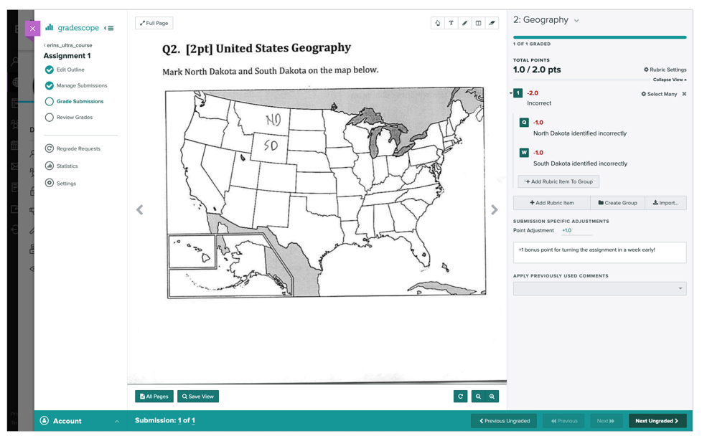

Posting grades
Troubleshooting: If you encounter any issues while trying to post grades from Gradescope to Blackboard, please see our troubleshooting section on grade-posting issues at the end of this article. If the solutions there don't work or the problem you're trying to solve isn't listed, please contact help@gradescope.com.
- First, make sure you've synced your roster.
- Then launch your graded assignment in Gradescope, expand the left sidebar (if it isn't already) and click Review Grades. On the Review Grades page in Gradescope, scroll down and click Post Grades to Blackboard.
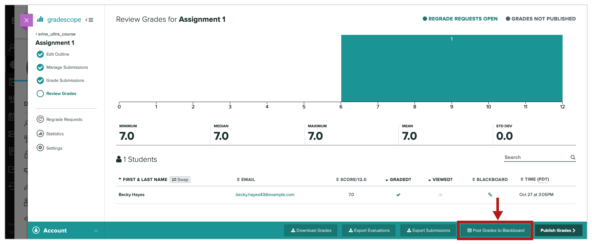
- When the dialog box appears, click Post Grades. These grades will now appear in your gradebook in Blackboard. Keep in mind that posting grades to Blackboard will only post the students' final assignment scores from Gradescope to the corresponding Blackboard grade column or gradebook item. Only grades for fully graded submissions (which have a checkmark in the Graded column on the Review Grades page) will be posted.
If you don't see a Post Grades button: Go to your Blackboard course. Click your Gradescope assignment link there to launch it. Click Review Grades (left sidebar in Gradescope). The Post Grades button should be in the footer of the Review Grades page now. If that didn't work, contact help@gradescope.com.

- If you want students to also see their graded, annotated submissions, question-by-question scores, rubrics, and feedback on Gradescope, click the Publish Grades button. If you'd like to, click the Compose Email to Students button at the bottom of the Review Grades page in Gradescope to alert students via email that their grades are now visible. To see what your students will see when they view their grades, check out the article on Using Gradescope with Blackboard as a Student.

Troubleshooting

Roster-syncing issues
Issue | Solution
I can only sync part of my roster. | If some members of your course can’t be synced along with the rest of your roster, most likely, these members do not have an email address associated with their account in Blackboard. To fix the issue, either ask the course members or your Blackboard admin to add the email addresses to the accounts in Blackboard. Then re-sync the roster.
I can't sync my roster at all. | Please contact help@gradescope.com.
After I unlink a Blackboard course from Gradescope, the initially synced roster will remain on the Roster page even after I link a new course. | Please contact help@gradescope.com to have the excess students removed. Alternatively, if there are no assignments within the course, you can delete it and create a new one to link with Gradescope.

Grade-posting issues
Issues | Solutions
I can't post grades from Gradescope to Blackboard. | Re-sync the roster in Gradescope.  Next, go to your Review Grades page in Gradescope. Make sure a teal checkmark appears for each student in the Graded column. If a student is missing a checkmark, but they submitted work, go to the Manage Submissions, open their submission, and make sure you gave them a score on every question.  Then click Post Grades to Blackboard again. If that doesn't work, please contact help@gradescope.com.

Embedded window issues
Issues | Solutions
Gradescope doesn’t appear in the embedded window when I use the Safari browser | To use Gradescope in an embedded window within Blackboard, select Preferences from Safari’s settings and then ensure Prevent cross-site tracking is unchecked.
Gradescope doesn’t appear in the embedded window when I use Chrome in incognito mode | Third-party cookies may be blocked which will prevent this functionality.  To temporarily enable third party cookies, select the eye icon on the right of the URL address bar when you attempt to launch Gradescope LTI. A modal will appear where you can select "Site not working?" and then Allow cookies. This setting will reset when you restart your browser.  To permanently allow third-party cookies, go to https://support.google.com/chrome/answer/95647. Select Privacy and security and then Cookies and other site data. Here you will be able to Allow all cookies. This setting will remain unless you return to the settings and disable it.

