Using Gradescope with Blackboard as a Student
[Gradescope article adapted for Syracuse University]

Accessing Gradescope
When you access Gradescope through Blackboard, you will not need separate Gradescope credentials, even if you are a new Gradescope user. If you already have a Gradescope account under the email address that's associated with your Blackboard account (e.g., your school email), when you access Gradescope in Blackboard you will be taken to your existing account. If you do end up with multiple accounts under multiple emails, you can merge accounts.
If your course is in Blackboard Original, your Gradescope course link will be under Tools in your Blackboard course. If your school uses the latest version of the Blackboard-Gradescope integration, your instructor may also give you direct links to each Gradescope assignment on your Content page. If your course is in Blackboard Ultra, your Gradescope course link will be under Books & Tools or on your Course Content page in Blackboard. If your school uses the latest version of the Blackboard-Gradescope integration, your instructor may also give you direct links to each Gradescope assignment on your Course Content page. If you have any problems accessing your Gradescope account, courses, or assignments see the Troubleshooting section at the end of this page.

Submitting assignments
- Log in to Blackboard. Then click the appropriate course.
- In your Blackboard course, there are a couple of places you should check to get to your Gradescope assignment. First, check your Content (Blackboard Original) or Course Content (Blackboard Ultra) page for a direct link to your Gradescope assignment. If you're using Blackboard Ultra, you may have a Gradescope course link on your Blackboard Course Content page also. If you don't see an assignment or course link anywhere else, click Tools (Original) or Books & Tools (Ultra), click Gradescope, wait for your Gradescope course to launch, and then select your assignment.
- Once your assignment opens in Gradescope, based on your instructor's settings, you could see instructions to upload PDFs or images, link code repositories, or start answering questions online. If you need help, check out the in-depth articles on scanning work and how you may be asked to submit your assignment. Keep in mind that if you encounter an error message trying to access your Gradescope assignment, the assignment may not be released to students yet.
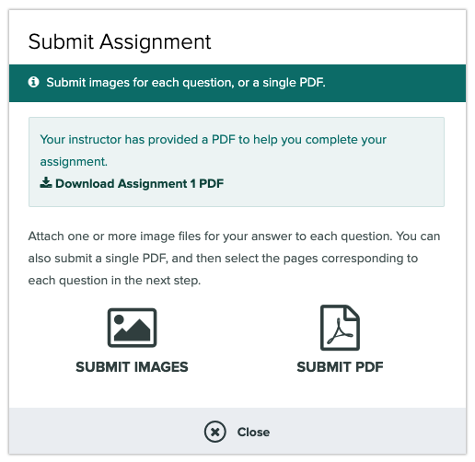
- Once you've submitted the assignment, if your instructor has allowed it, you can view your submission. If you don't have that option, then you will be able to view your work when your instructor publishes grades.

Viewing grades and submissions
- Log in to Blackboard. Next, click Grades or My Grades in the left sidebar (terminology can differ by Blackboard version). Then click your course and Gradescope assignment. If your instructor has posted grades to Blackboard, you will see your overall assignment grade as shown in the following image.
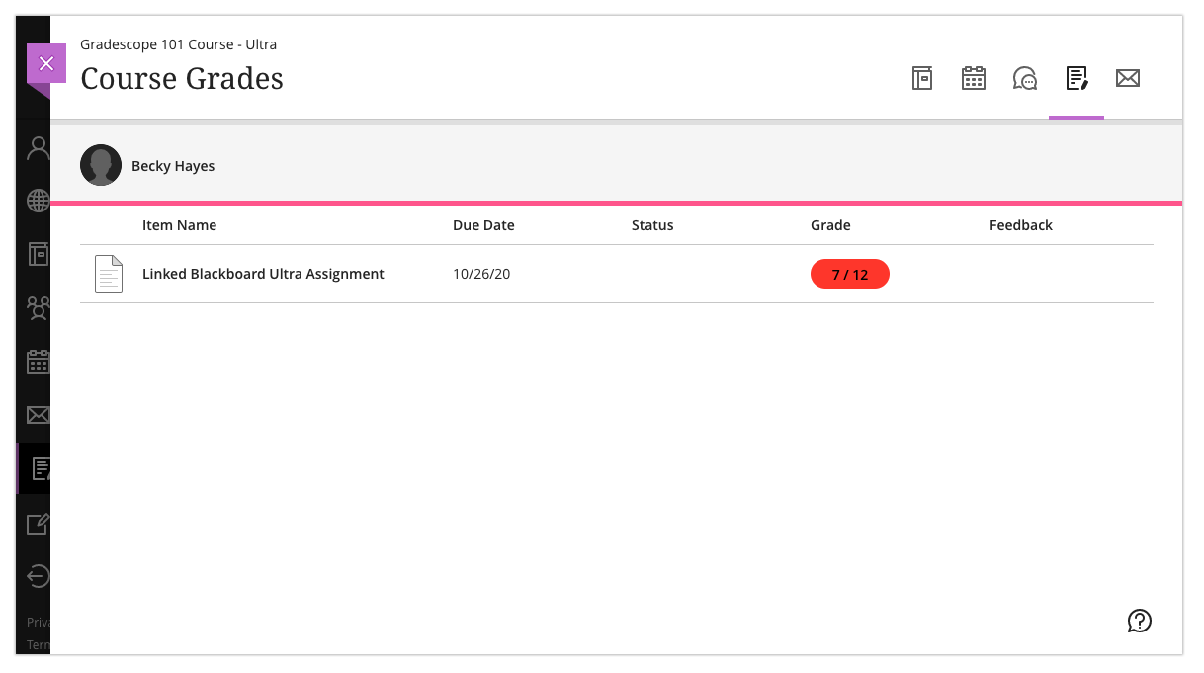
- To view your submission and feedback, launch your assignment in Gradescope the same way you did when you were submitting your work. See Step 2 of the Submitting Assignments section above if you forgot how.
- Once your assignment is open in Gradescope, if your instructor has published grades, you will be able to see them along with your submission, points breakdown, and any comments your instructor gave you.
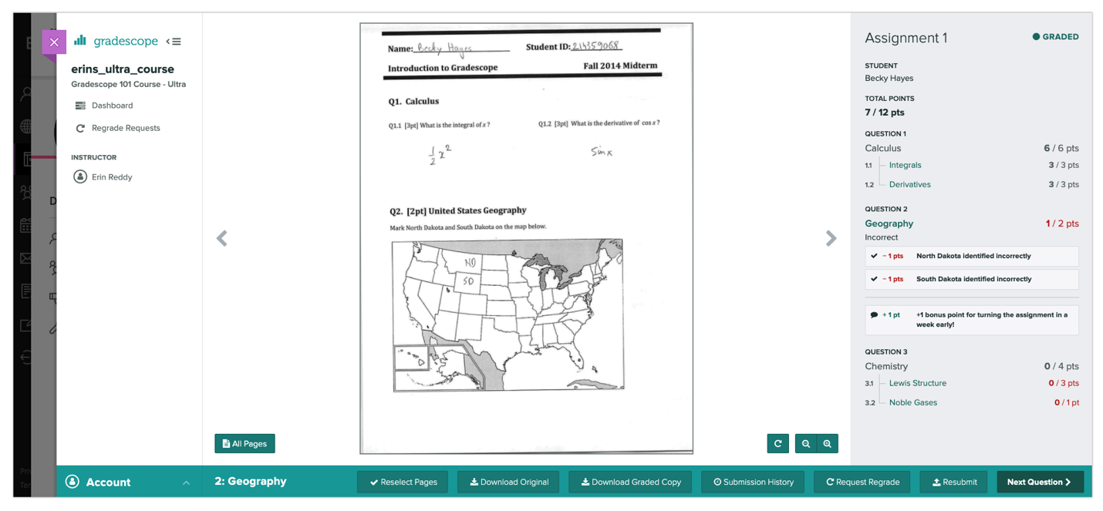

Troubleshooting
If you don't see a Gradescope course link under Tools (Original) or Books & Tools or Course Content (Ultra), and if you do not have a direct assignment link on your Content (Original) or Course Content (Ultra) page in Blackboard, your instructor may not have linked Gradescope to your course correctly or at all.
If Gradescope doesn’t appear within the embedded window in Blackboard, you may need to make some small changes to your browser settings.
- Safari - Select Preferences from Safari’s settings and then ensure Prevent cross-site tracking is unchecked
- Incognito mode in Chrome - Access https://support.google.com/chrome/answer/95647. Select Privacy and security and then Cookies and other site data. Here you will be able to Allow all cookies.
If you need any help, email help@gradescope.com.

