Higher Education Landscape
This exercise can help examine current trends in higher education. Consider: demographic shifts, opportunities and threats for enrollment, identify faculty/staff employment trends and anticipate hiring needs, list key areas of competition and consider implications of shifts in competitors’ growth, and identify technology needs. Below is an example of an Agriculture School.
Technology
- New user-friendly version of LMS system was introduced - need to allocate funding.
- Hybrid learning is in demand - consider outfitting 20 classrooms more.
- With new online courses there may be a need for virtual labs.
Demographics
- Adult student population increases -consider evening courses.
- 10% increase in Asian students - consider opening Asian Center.
- Generation Z is a diverse population - focus on diversity and inclusion.
Competition
- Peer institutions have launched weekends-only transfer degree - need to consider weekend course offerings.
- Peer institutions have launched a program similar to ours - need to consider competitive advantage.
- The number of competency based programs is increasing - implement more competency-based programs.

Faculty/Staff
- The number of expected retirees is high - need to start hiring process.
- One third of the faculty are adjuncts -implement ten - year track hiring.
- The institution is a predominantly White institution - focus on retaining faculty and staff of color.
Enrollment
- Decrease in the number of students enrolled from feeder schools - need to increase recruiting efforts.
- College-age population is expected to drop 5% in the Northeast and Midwest - develop on-line programs.
- High discount rates led to slower growth in tuition revenue - consider increase in subsidies.
Accreditation
- Review the last self-study prepared for self-accreditation.
- Take actions on any accreditation recommendations and ensuring there is an ongoing process to maintain and exceed accreditation standards.
- Ensure regular periodic and final assessment of self-study and strategic planning to determine if specific goals are met.

Career and Societal
- Employer demand will exceed the supply of available graduates with a bachelor’s degree or higher by 2.6 percent in the next five years – ensure there is an opportunity to increase the number of spots in programs.
- There is a strong demand for graduates with expertise in data science - review the curriculum of the programs.

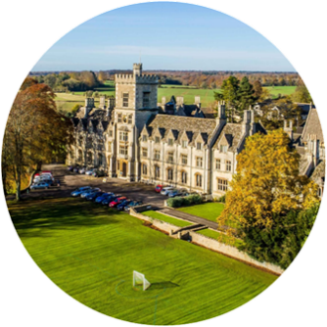

Higher Education Landscape
In the space below, explore the higher education landscape as it relates to your area.
Technology

Demographics

Competition

Faculty/Staff

Enrollment

Accreditation

Career and Societal

