RUBRICS PACKET: 2016
WORKSHOP: Dannelle D. Stevens, Ph.D., stevensd@pdx.edu
Contents:
1. Example of a rubric
2. Blank rubric: 3 to 5 level (2 pages)
3. Stickies to descriptions: Explanation
4. Bloom’s taxonomy: Old and new- three examples
5. References on rubrics

Changing Communities in Our City

Task Description: Each student will make a 5 minute presentation on the changes in one Portland community over the past 30 years. The student may focus the presentation in any way s/he wishes, but there needs to be a thesis of some sort, not just a chronological exposition. The presentation should include appropriate photographs, maps, graphs, and other visual aids for the audience.

 | Excellent | Competent | Needs work
Knowledge/  Understanding  20% | The presentation demonstrates a depth of historical understanding by using relevant and accurate detail to support the student’s thesis.  Research is thorough and goes beyond what was presented in class or in the assigned texts. | The presentation uses knowledge which is generally accurate with only minor inaccuracies, and which is generally relevant to the student’s thesis.  Research is adequate but does not go much beyond what was presented in class or in the assigned text. | The presentation uses little relevant or accurate information, not even that which was presented in class or in the assigned texts.  Little or no research is apparent.
Thinking/  Inquiry  30% | The presentation is centered around a thesis which shows a highly developed awareness of historiographic or social issues and a high level of conceptual ability. | The presentation shows an analytical structure and a central thesis, but the analysis is not always fully developed and/or linked to the thesis. | The presentation shows no analytical structure and no central thesis.
Communication  20% | The presentation is imaginative and effective in conveying ideas to the audience.  The presenter responds effectively to audience reactions and questions | Presentation techniques used are effective in conveying main ideas, but a bit unimaginative.  Some questions from the audience remain unanswered. | The presentation fails to capture the interest of the audience and/or is confusing in what is to be communicated.
Use of visual aids  20% | The presentation includes appropriate and easily understood visual aids which the presenter refers to and explains at appropriate moments in the presentation. | The presentation includes appropriate visual aids, but these are too few, in a format that makes them difficult to use or understand, and/or the presenter does not refer to or explain them in the presentation. | The presentation includes no visual aids or visual aids that are inappropriate, and/or too small or messy to be understood.  The presenter makes no mention of them in the presentation.
Presentation skills  10% | The presenter speaks clearly and loudly enough to be heard, using eye contact, a lively tone, gestures, and body language to engage the audience. | The presenter speaks clearly and loudly enough to be heard, but tends to drone and/or fails to use eye contact, gestures, and body language consistently or effectively at times. | The presenter cannot be heard and/or speaks so unclearly that s/he cannot be understood.  There is no attempt to engage the audience through eye contact, gestures, or body language.

Figure 1.6: Part Four: 3 Level Rubric: Description of Dimensions with all levels of performance described. . © Stevens, D. D. & Levi, A. J. (2005). Introduction to Rubrics. Sterling, VA: Stylus Press.

Three LEVEL RUBRIC

TASK DESCRIPTION:

DIMENSIONS | BEGINNING | COMPETENT | EXEMPLARY

Three LEVEL RUBRIC

TASK DESCRIPTION:

DIMENSIONS | BEGINNING | COMPETENT | EXEMPLARY

Rubrics:
Writing high quality descriptions of dimensions by levels of performance.

Your stickies:
Dimension:

Engagement
 |  | Good eye contact |  | Raises hand to ask questions |  | Takes notes |  | Asks questions that relate to lecture

Big question: How do you go from stickies to descriptions on the rubric?
Dimension | Exceptional | Competent | Needs work
Engagement | Student maintains consistent eye contact with instructor and peers.  Student always raises hand to ask or answer questions.  Student always takes notes on lecture.  Student asks appropriate questions about the lecture. | Student usually makes eye contact with instructor or peers.  Student frequently raises hand to ask or answer questions.  Student usually takes notes and is not distracted.  Student generally asks appropriate questions related to content. | Student seldom makes contact with instructor or peers. Student looks down at schoolwork or is engaged in non-class activity.  Student seldom or never raises hand to ask questions.  Student does not take notes in class and appears to be distracted by non-class things.  Student never asks questions.

Example from rubric in your packet:
What are the key words that signal levels of performance?
 | Exemplary | Competent | Needs work
Communication  20% | The presentation is imaginative and effective in conveying ideas to the audience.  The presenter responds effectively to audience reactions and questions | Presentation techniques used are effective in conveying main ideas, but a bit unimaginative.  Some questions from the audience remain unanswered. | The presentation fails to capture the interest of the audience and/or is confusing in what is to be communicated.
Another example
 | Exceptional | Competent | Beginning
LISTENING | Student always seems to listen with eyes on instructor and peers.  When asked, student quickly communicates understanding of the material that is discussed in class. | Student often listens to instructor and other students.  Student frequently communicates understanding of material that is discussed in class. | Student does not seem to be listening. Students looks down at his/her materials most of the time.  When asked, the student is not able to communicate understanding of the material discussed in class.

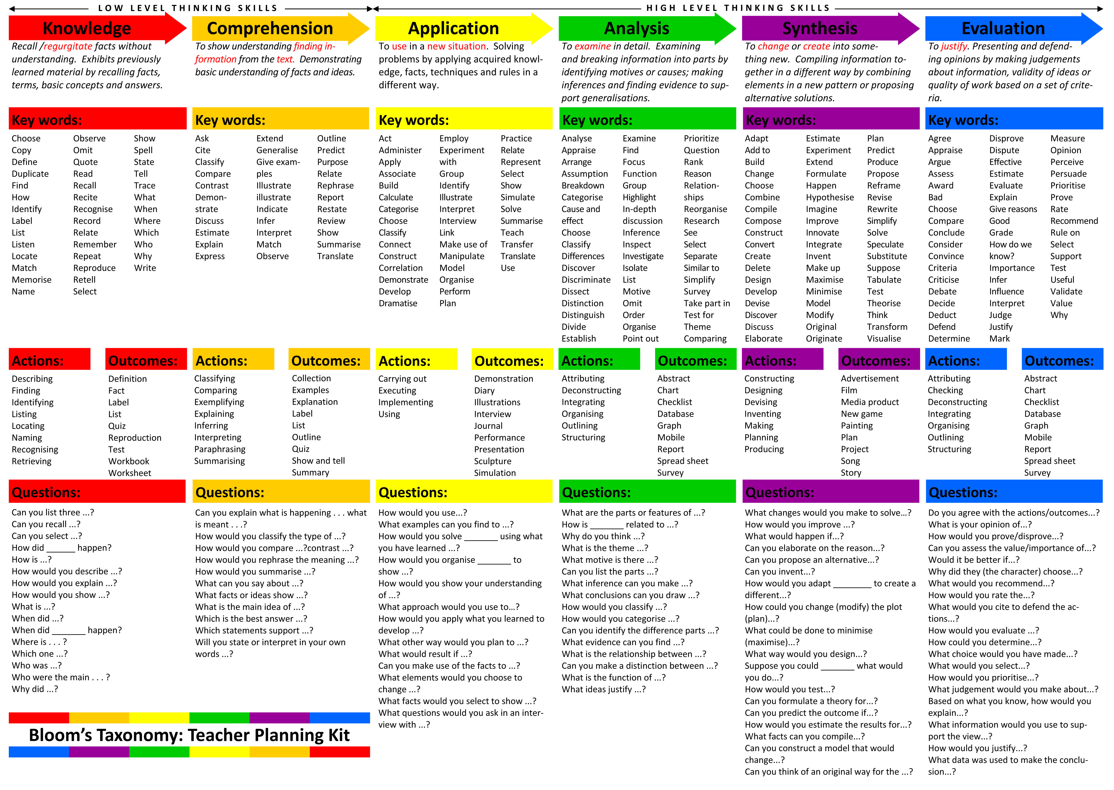

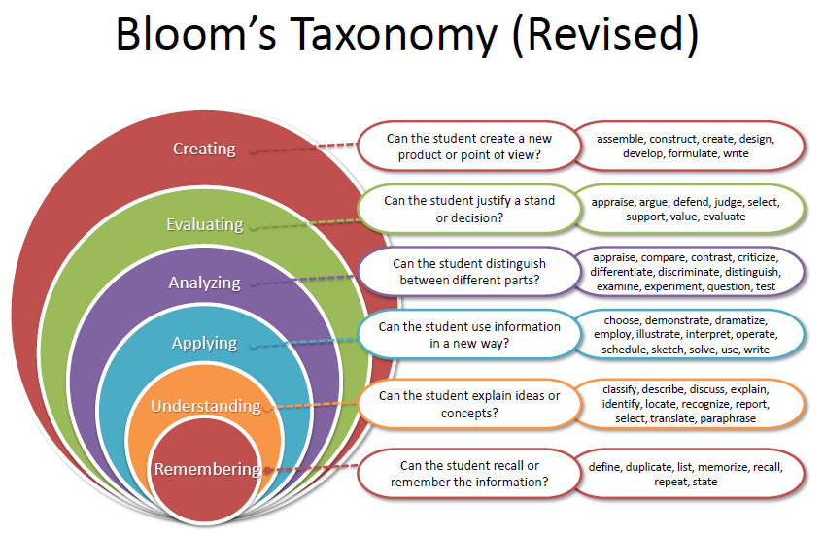

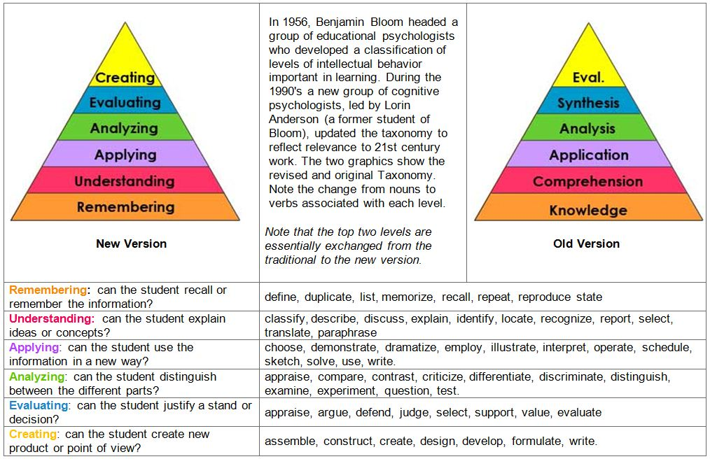I Selected

Selected references on rubrics: Compiled by Dannelle D. Stevens, 2016
Bremer, M. H., Gonzalez, E., & Mercado, E. (2010). Teaching Creativity and Innovation Using Sustainability as Driving Force. International Journal of Engineering Education, 26(2), 430–437.
Brookes, D. T., & Lin, Y. (2010). Structuring Classroom Discourse Using Formative Assessment Rubrics. AIP Conference Proceedings, 1289(1), 5–8. http://doi.org/10.1063/1.3515248
Brookhart, S. M., & Chen, F. (2015). The quality and effectiveness of descriptive rubrics. Educational Review, 67(3), 343–368. http://doi.org/10.1080/00131911.2014.929565
Cebrian-De-La-Serna, M., Serrano-Angulo, J., & Ruiz-Torres, M. (2014). eRubrics in Cooperative Assessment of Learning at University. Las eRúbricas En La Evaluación Cooperativa Del Aprendizaje En La Universidad., 22(43), 153–161. http://doi.org/10.3916/C43-2014-15
Christopher, M. M., Thomas, J. A., & Tallent-Runnels, M. K. (2004). Raising the bar: Encouraging high-level thinking in online discussion forums. Roeper Review, 26(3), 166–171.
Harks, B., Rakoczy, K., Hattie, J., Besser, M., & Klieme, E. (2014). The effects of feedback on achievement, interest and self-evaluation: the role of feedback’s perceived usefulness. Educational Psychology, 34(3), 269–290. http://doi.org/10.1080/01443410.2013.785384
Hattie, J., & Jaeger, R. (1998). Assessment and Classroom Learning: a deductive approach. Assessment in Education: Principles, Policy & Practice, 5(1), 111–122. http://doi.org/10.1080/0969595980050107
Hattie, J., & Timperley, H. (2007). The Power of Feedback. Review of Educational Research, 77(1), 81–112. http://doi.org/10.3102/003465430298487
Howell, R. J. (2014). Grading rubrics: hoopla or help? Innovations in Education & Teaching International, 51(4), 400–410. http://doi.org/10.1080/14703297.2013.785252
Isaacson, J. J., & Stacy, A. S. (2009). Rubrics for clinical evaluation: Objectifying the subjective experience. Nurse Education in Practice, 9(2), 134–140. http://doi.org/10.1016/j.nepr.2008.10.015
Jonsson, A. (2014). Rubrics as a way of providing transparency in assessment. Assessment & Evaluation in Higher Education, 39(7), 840–852. http://doi.org/10.1080/02602938.2013.875117
Lillis, T., & Turner, J. (2001). Student Writing in Higher Education: Contemporary confusion, traditional concerns. Teaching in Higher Education, 6(1), 57–68. http://doi.org/10.1080/13562510020029608
Mansilla, V. B., Duraisingh, E. D., Wolfe, C. R., & Haynes, C. (2009). Targeted Assessment Rubric: An Empirically Grounded Rubric for Interdisciplinary Writing. Journal of Higher Education, 80(3), 334–353.
Peat, B. (2006). Integrating writing and research skills: Development and testing of a rubric to measure student outcomes. Journal of Public Affairs Education, 12(3), 295–311.
Piedra, N., Chicaiza, J., López, J., Romero, A., & Tovar, E. (2010). Measuring collaboration and creativity skills through rubrics: Experience from UTPL collaborative social networks course. In Education Engineering (EDUCON), 2010 IEEE (pp. 1511–1516). IEEE. Retrieved from http://ieeexplore.ieee.org/xpls/abs_all.jsp?arnumber=5492349
Reddy, Y. M., & Andrade, H. (2010). A review of rubric use in higher education. Assessment & Evaluation in Higher Education, 35(4), 435–448. http://doi.org/10.1080/02602930902862859
Rodriguez, A. (2008). The “Problem” of Creative Writing: Using Grading Rubrics Based On Narrative Theory as Solution. New Writing, 5(3), 167–177. http://doi.org/10.1080/14790720802209963
Stevens, D. d. & Levi, A. (2013). Introduction to rubrics: An assessment tool to
Wyss, V., Freedman, D., & Siebert, C. (2014). The Development of a Discussion Rubric for Online Courses: Standardizing Expectations of Graduate Students in Online Scholarly Discussions. TechTrends: Linking Research & Practice to Improve Learning, 58(2), 99–107.

